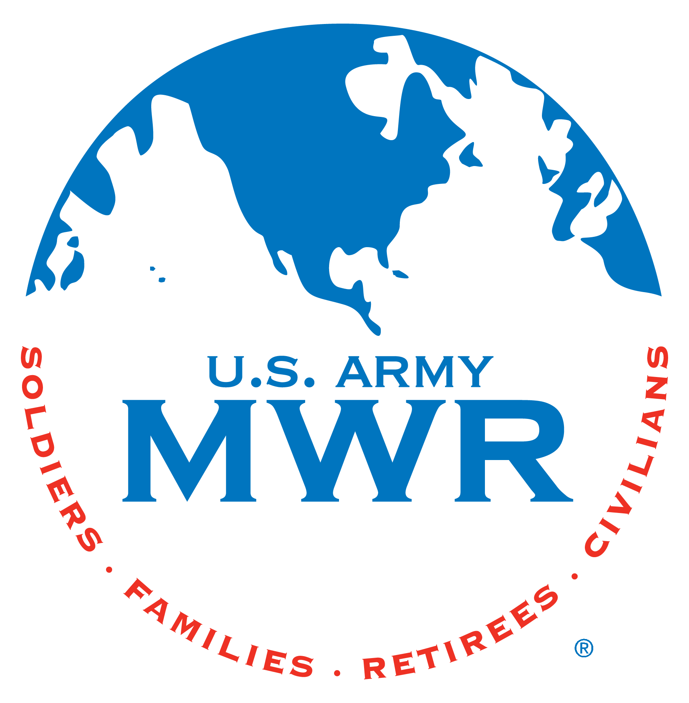MWR Aquatics
Aquatics office: 337-531-6785/1988
25 Meter Party Reservation Form
POC: ______________________________________________________________
Alternate: __________________________________________________________
Phone Number: _____________________________________________________
Date and time of event: _______________________________________________

DAY PARTIES (TO BE SHARED WITH THE PUBLIC)
____ $55 – A maximum of 20 guests
____ $70 – for up to 49 people of less.
One table will be reserved in the grassy area for your party. The party will start at the time indicated and will end two hours after the set time. Once the party ends, everyone must vacate or pay the regular admission price. Only the POC will be allowed in prior to the set time to set up.
A few Reminders:
All patrons must adhere to ALL regular pool rules.
NO alcoholic beverages are allowed.
NO Water wings.
NO swim diapers are allowed in the 25-meter pool.
Children must be potty trained to enter the 25-meter pool.
Parties must be canceled 48 hours in advanced or the deposit will not be returned.
If the pool party is scheduled during open swim hours, the customer agrees to share with the public.
I understand and agree to all of the above: _______________________________
Date: _______________

The deposit has been paid and the patron has been verified as an authorized user of MWR.

